A532-Mex-Jalisco-Warrior with Horned Headdress-Holding Club-Terra Cotta-100 BCE

 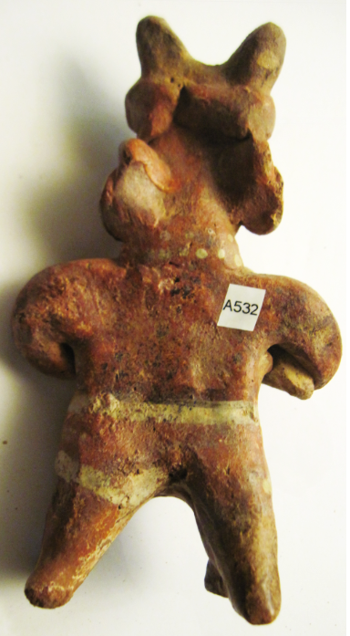

**Case No.: 9**

**Accession No.**

**Formal Label:** Mex-Jalisco-Warrior with Horned Headdress-Holding Club-Terra Cotta-100 BCE

**Display Description:**

The warrior wears a horned helmet, possibly of wood or wicker. In his hands he brandishes a club or a short spear that has broken. The stance, weapon and armor of the warrior are similar to many found throughout the area of the Shaft Tombs. The number of warrior figures found, and the level to which they were armed, indicates that this period in Western Mexico was not entirely peaceful.

These warriors were placed in Jalisco tombs to ward off any who might seek to disturb those interred in these shaft tomb graves.

**LC Classification:**

**Date or Time Horizon:** 100 BCE

**Geographical Area:**

**Map:**

[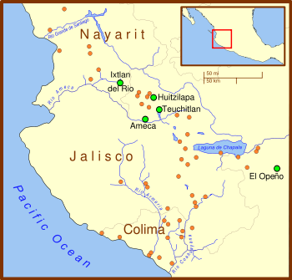](https://en.wikipedia.org/wiki/File:Ancient_Western_Mexico_Archaeological_Sites.svg)

Western Mexico archaeological sites. The orange circles show archaeological sites. The larger green circles highlight the most important sites. Note that the sites form what has been called the "shaft tomb arc" which extends from northwest Nayarit through the central Jalisco highlands and down to Colima. After https://upload.wikimedia.org/wikipedia/commons/thumb/d/d3/Ancient_Western_Mexico_Archaeological_Sites.svg/525px-Ancient_Western_Mexico_Archaeological_Sites.svg.png

**GPS coordinates:**

**Cultural Affiliation: Jalisco**

**Medium: ceramic, red, black and white pigment**

**Dimensions:**

**Weight:**

**Condition: original**

**Provenance:**

**Discussion:**

The Western Mexico shaft tomb tradition or shaft tomb culture refers to a set of interlocked cultural traits found in the western Mexican states of Jalisco, Nayarit, and, to a lesser extent, Colima to its south. Built beneath house platforms, these tombs served as family mausoleums and were periodically opened to inter the recently deceased.

**References:**